Mindfulness, Oprah, and the Smiling Meditation of Thich Nhat Hahn
By Barrie Davenport Get your free starter kit HERE
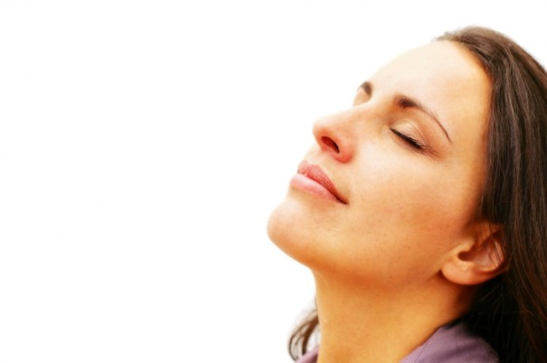
“Breathing in I calm body and mind. Breathing out, I smile.” ~Thich Nhat Hahn
There is more power in a smile than you may have ever contemplated.
Yesterday I was driving to pick my daughter up from school and tuned in to Oprah Radio on XM radio. I was delighted to hear an interview she was conducting (from 2010) with Vietnamese Buddhist monk Thich Nhat Hahn (pronounced tic not han). He is called “Thay” (teacher in Vietnamese) by his students. For the sake of brevity, this is what I’ll call him in this post.
In a discussion about happiness, Thay said something to Oprah that opened a new level of awareness for me, and I hope for you.
First, if you don’t know Thay, here’s a brief introduction.
He’s been a Buddhist monk for more than 60 years. He is also a poet and the author of Being Peace, The Miracle of Mindfulness, Living Buddha, Living Christ, and many other books. He gave birth to the movement of “Engaged Buddhism”— peaceful activism for the purpose of social reform. Because of his stance against the Vietnam War, he was exiled from his own country. It also led Martin Luther King Jr. to nominate him for a Nobel Peace Prize in 1967.
He lives in a monastic community in south-western France called Plum Village , where he teaches, writes, gardens, and works to help refugees world-wide. (No matter what your faith, I encourage you to read more about this amazing man.)
So back to the Oprah interview — Oprah asked Thay about happiness. I found the transcript of the interview, and here’s what he had to say about happiness:
Oprah: What is happiness?
Nhat Hanh: Happiness is the cessation of suffering. Well-being. For instance, when I practice this exercise of breathing in, I’m aware of my eyes; breathing out, I smile to my eyes and realize that they are still in good condition. There is a paradise of form and colors in the world. And because you have eyes still in good condition, you can get in touch with the paradise. So when I become aware of my eyes, I touch one of the conditions of happiness. And when I touch it, happiness comes.
Oprah: And you could do that with every part of your body.
Nhat Hanh: Yes. Breathing in, I am aware of my heart. Breathing out, I smile to my heart and know that my heart still functions normally. I feel grateful for my heart.
Oprah: So it’s about being aware of and grateful for what we have.
Nhat Hanh: Yes.
Oprah: And not just the material things, but the fact that we have our breath.
Nhat Hanh: Yes. You need the practice of mindfulness to bring your mind back to the body and establish yourself in the moment. If you are fully present, you need only make a step or take a breath in order to enter the kingdom of God. And once you have the kingdom, you don’t need to run after objects of your craving, like power, fame, sensual pleasure, and so on. Peace is possible. Happiness is possible. And this practice is simple enough for everyone to do.
Oprah: Tell me how we do it.
Nhat Hanh: Suppose you are drinking a cup of tea. When you hold your cup, you may like to breathe in, to bring your mind back to your body, and you become fully present. And when you are truly there, something else is also there—life, represented by the cup of tea. In that moment you are real, and the cup of tea is real. You are not lost in the past, in the future, in your projects, in your worries. You are free from all of these afflictions. And in that state of being free, you enjoy your tea. That is the moment of happiness, and of peace. When you brush your teeth, you may have just two minutes, but according to this practice, it is possible to produce freedom and joy during that time, because you are established in the here and now. If you are capable of brushing your teeth in mindfulness, then you will be able to enjoy the time when you take a shower, cook your breakfast, sip your tea.
Oprah: So from this point of view, there are endless conditions of happiness.
Nhat Hanh: Yes. Mindfulness helps you go home to the present. And every time you go there and recognize a condition of happiness that you have, happiness comes.
Oprah: With you, the tea is real.
Nhat Hanh:I am real, and the tea is real. I am in the present. I don’t think of the past. I don’t think of the future. There is a real encounter between me and the tea, and peace, happiness and joy are possible during the time I drink.
(From the March 2010 issue of O, The Oprah Magazine)

When I heard him speak of breathing in and having awareness of his eyes or heart and breathing out and smiling to them, I was struck by the beautiful simplicity of this action.
Not smiling at them — but smiling to them. This subtle distinction actually is a huge shift, engaging your full being with the awareness of your eyes or heart or whatever you are aware of in the moment. It’s offering the gift of your full awareness and receiving happiness in return.
This interview compelled me to do a bit more research around smiling meditations. I learned that smiling is used as a healing and meditation practice by many ancient cultures. Taoists have long believed that having a smile on your face and directing it inwards towards your organs and inner body is essential to good health and longevity.
Balinese healers believe that a smile clears away negative energy and practice smiling meditation as a simple way to calm the mind and bring healing to the soul.
Then I found this amazing excerpt from Thich Nhat Hahn’s book Being Peace:

During walking meditation, during kitchen and garden work, during sitting meditation, all day long, we can practice smiling. At first you may find it difficult to smile, and we have to think about why. Smiling means that we are ourselves, that we are not drowned into forgetfulness. This kind of smile can be seen on the faces of Buddhas and Bodhisattvas.
I would like to offer one short poem you can recite from time to time, while breathing and smiling.
Breathing in, I calm body and mind.
Breathing out, I smile.
Dwelling in the present moment
I know this is the only moment.
“Breathing in, I calm body and mind.” This line is like drinking a glass of ice water–you feel the cold, the freshness, permeate your body. When I breathe in and recite this line, I actually feel the breathing calming my body, calming my mind.
You know the effect of a smile. A smile can relax hundreds of muscles in your face, and relax your nervous system. A smile makes you master of yourself. That is why the Buddhas and Bodhisattvas are always smiling. When you smile, you realize the wonder of the smile. “Dwelling in the present moment.” While I sit here, I don’t think of somewhere else, of the future or the past. I sit here and I know where I am. This is very important.
We tend to be alive in the future, not now. We say, “Wait until I finish school and get my Ph. D. degree, and then I will be really alive.” When we have it, and it’s not easy to get, we say to ourselves, “I have to wait until I get a job, in order to be *really* alive.”
And then after the job, a car. After the car, a house. We are not capable of being alive in the present moment. We tend to postpone being alive to the future, the distant future, we don’t know when. Now is not the moment to be alive. We may never be alive in our entire life.
Therefore, the technique, if we have to speak of a technique, is to be in the present moment, to be aware that we are here and now, and the only moment to be alive is the present moment. “I know this is the only moment.” This is the only moment that is real. To be here and now, and enjoy the present moment is our most important task. “Calming. Smiling, Present moment, Only moment.” I hope you will try it.
Sometimes the simplest ideas and actions can have the most profound impact on your well-being. Take a moment right now. Breathe in and be aware of the present moment. Breathe out and smile to it.
If you would like to create a life-long habit of smiling meditation or any new, positive habit, please consider joining The Habit Course with me, Leo Babauta, and Katie Tallo. Registration is on-going through Monday, October 3 at 9:00 a.m. Eastern, when the course begins.
- See more at: http://liveboldandbloom.com/09/self-improvement/mindfulness-oprah-and-the-smiling-meditation-of-thich-nhat-hahn-2#sthash.rn0H3m2W.dpuf

